INSTITUTE OF MATHAMETICS AND COMPUTER SCIENCE



BS (COMPUTER SCIENCE) PART IV

TITLE OF THE PROJECT
IMCS LAB MANAGEMENT SYSTEM

GROUP | NAME | ROLL NO
Group Leader | IFTIKHAR AHMED | 2k20/CSE/48
Group Leader | KABEER AHMED | 2k20/CSE/57

PRESENTED BY
IFTIKHAR AHMED
&
KABEER AHMED

ASSIGNED BY
Mr. Habibullah Nangraj

UNIVERSITY OF SINDH JAMSHORO.
MAY 23, 2023

1. INTRODUCTION
This lab management system is a project where we can generate information about labs which pc working which pc not working and which pc under maintenance. The purpose of the project is to generate reports are coding to the employee needs where we can maintain the cpu through the reports. The scope of this system is to develop LAN based control system that can monitor the activities of terminal in computer laboratory.
SCOPE OF THE PROJECT
The Computer Hardware and Peripherals Maintenance Contract could be fully Comprehensive Onsite Maintenance Contract or could be arranged to be on Time and Material Bases. Maintenance service shall consist of Preventive and Breakdown / Corrective maintenance of all the organizations related IT Hardware Assets and Network Infrastructure. It should take corrective and remedial maintenance services to set right the reported malfunctioning of IT related infrastructure at the specified locations.

3. METHODOLOGY

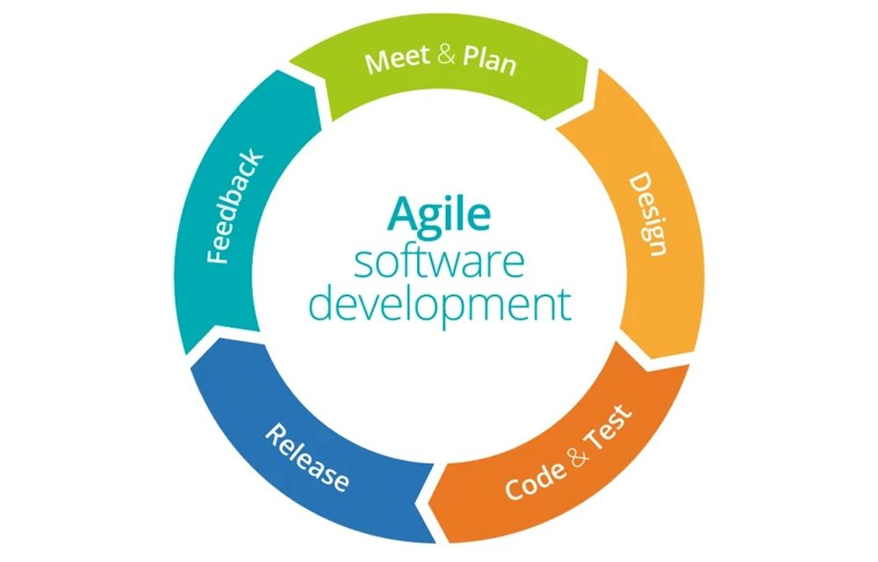
3.1 TOOLS AND TECHNIQUE
- Visual Studio
- Crystal Report
- SQL Server
- C#

3.2 ENTITY RELATIONSHIP DIAGRAM (ERD)

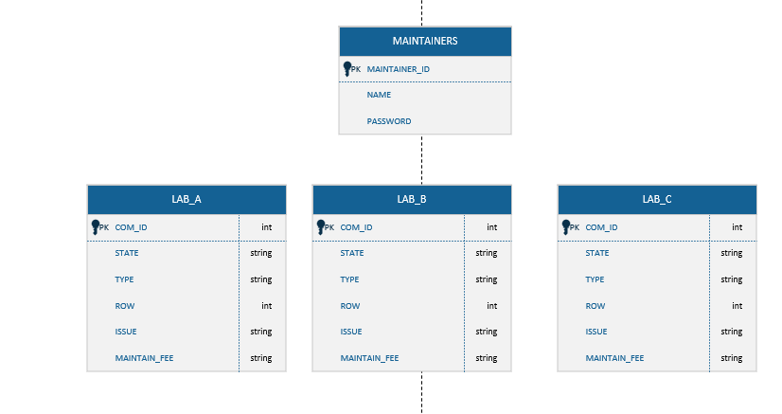

4. CONCLUSION
This study will be conducted to manage the computer laboratory at IMCS in a systematic and effective manner. A Computer-based computer lab management will be developed to provide facilities for employees to make a maintain lab computer, to log the use of computer by students, and produce reports about the computer lab utilization to the management of IMCS and education authority. Teachers do not have to wait on computer to be repaired in computer lab. They can perform a report in anywhere and at any time through the windows application. Reports on the analysis of the use of computer laboratories will be submitted to the education authority periodically

